PlaneRay modeling of underwater sound propagation

Abstract
PlaneRay is a ray-tracing program for modeling of underwater acoustic propagation in the oceans. The sound speed of the water may vary with depth, but not with range. The model accepts moderately range-varying bathymetry with a bottom modelled as a fluid sedimentary over an elastic half space. Rays are not traced into the bottom; the bottom interaction is modeled by local plane-wave reflection coefficients. The model uses a unique sorting and interpolation routine to determine the eigenrays connecting a source with receivers positioned on a horizontal line. For each eigenray, the model calculates the trajectories, travel times and amplitudes and constructs the complete frequency-domain transfer function by coherent addition of all contributions of the multiple arrivals. Multiplying with the spectrum of a source signal followed by Fourier transformation yields the time responses of the received signals. A unique feature of the model is that the contribution of the various multipath arrivals are evaluated separately, thereby enabling the user to study the structure of the field in detail. This report gives a description of the model with a presentation of illustrative cases.

Introduction
Ray tracing modeling derives from a high-frequency approximation of the wave equation and are conventionally considered appropriate only for active sonar frequencies. However, ray trace models may be more accurate than commonly believed, also for low frequency applications. Ray tracing models are computationally efficient since the main calculation of ray trajectories is independent of frequency; the frequency enters only through the interaction with the boundaries, sea surface and sea floor, and introduced separately. Ray representations of sound fields give a physical description of the wave field that is easier to understand and interpret than other types of field descriptions. Ray theory is found in the literature see for example references [1, 2] and the frequently used Bellhop model [3]. Other publications relevant for PlaneRay by the author are found in [4, 5, 6].
The PlaneRay model is written in Matlab and can therefore easily be modified by the users. The unique feature of the PlaneRay model is that contributions of the various multipath arrivals are evaluated separately using a method of sorting and classifications of rays. This method gives useful insight and understanding on how the sound field is composed and detailed information about the multipath structure. A valuable feature of the model may be the educational aspect and it usefulness in understanding the composition of an underwater wave field.
This report describes the PlaneRay model and presents typical examples of applications with for both range independent and range dependent scenarios. Results from testing and comparison with other propagation models are included. The discussions aim at illustrating the capability and limitations of the ray theory, and are partly of tutorial nature. PlaneRay is written by the author, mainly for educational purposes and containing many illustrative examples of acoustic underwater propagation. The code is free for use but with no guaranty for correctness. Please respect my intellectual property rights by referencing to PlaneRay in published work using the model.

Model description

General
The calculation is divided in three stages:
(1) The initial ray tracing using a large number of rays to map out the entire sound field and record the ray history.
(2) Sorting and interpolation to determine the ray parameters for the eigenrays connecting the source to the receivers. The ray parameters give the trajectories, travel times, and coordinates for surface and bottom interactions.
(3) Synthesis of the acoustic field in time and frequency domains by coherent addition of the contributions of the eigenrays followed by Fourier transformation
The input information to the Plane Ray model is a sound speed profile (SSP), the range-dependent bathymetry with a description of the geoacoustic structure of the bottom, and the depths of the source and receivers. The sound speed profile in the water is limited to be a function of depth only and cannot vary in the horizontal direction. Rays are only traced to the water-sediment interface and not into the bottom; the acoustic effects of the bottom are represented by plane ray reflections coefficients. The bottom may be layered and, in principle, any number of fluid and elastic layers is allowed, but in the current version, only a fluid sedimentary layer over an elastic half space is implemented. The initial ray tracing is done by launching a relative large number of rays with angles spanning the entire angular space between the source and receivers. A ray from the source position to given receiver position is called an eigenray. In general, there are many eigenrays for each pair of source and receiver position. The program determines the trajectories, travel times and amplitudes of all eigenrays. The respective eigenray contributions are summed coherently to produce the frequency-domain transfer function. The time responses of the received signals are obtained by multiplication with source spectrum followed by a Fourier transformation,
The implementation used in the PlaneRay model is to divide the water column into a large number of layers with the same thickness ∆z, which also is used as the depth increment in the calculations. Generally, the accuracy of the modeling improves with a finer depth increment. Typically, the layer thickness should to be about 1%, of the water depth. Within each layer, the sound speed is approximated with a straight line and the ray paths become circular arc. When the water depth is not constant, the ray parameter is no longer constant, but changes with the bottom inclination angle from θ_{in} to θ_{out,} and depending on the sign of the ray angle and the angle of bottom slope α according to
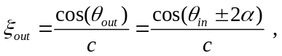
The acoustic intensity is calculated using the principle that the power within a space limited by a pair of rays with initial angular separation of dθ₀ and centered on the initial angle θ₀, will remain between the two rays regardless of the rays’ paths. The acoustic intensity I(r) as function of horizontal range is, according to this principle, given by
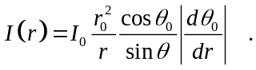
This equation predicts infinite intensity under two conditions, when θ =0 and when dr/dθ₀=0. The first condition defines a turning point where the ray path becomes horizontal; the second condition occurs at points where an infinitesimal increase in the initial angle of the ray produces no change in the horizontal range traversed by the ray. The locations where dr/dθ₀=0 are the caustics with infinite intensity as predicted by equation . In reality, there is focusing of energy to a high level, but the actual level is not determined by ray theory. The problem with calculation of the acoustic field at caustics and turning points represents a limitation of ray theory.

Initial ray tracing and generation of ray history records
The equations presented in chapter 6 of [4] are applied to calculate the trajectories for a number of rays spanning the whole range of initial angles that are relevant for the actual studies. For each ray, the ranges and the travel time to the intersections with the receiver depth are detected together with the angles and coordinates where the rays are reflected from the bottom and surface, and where the rays have gone through turning points. All this information, i.e. the ray history, is stored in the computer for later look-up.
Figure 1 shows an example with an undulating sloping bottom having a fluid sediment layer of 5 m thickness over hard bedrock. The sound speed profile is a summer for northern waters. The figure shows 100 ray trajectories from a source at 25 m depth with initial angles spanning the angular range from -30º to +30º.
Figure 2 displays parts of the ray history as function of initial angle at the source. The two plots show the ranges and travel times to locations where the rays cross the receiver depth line, which in this case is at a depth of 100 m. Reading off the intersections at a particular range gives the initial angles at the source, i.e. the eigenrays. A particular ray may intersect the receiver depth line at several ranges. For instance, the plots in Figure 2 show that at the range of 2 km there are 8 eigenrays. By reading the range-angle plot in Figure 2, the initial angles of these rays are found to be 7.5°, 12.9°, 23.2°, 26.8° for the positive (down going) rays and -9.5°, -14.9, ° -23.2° -28.8° , for the negative (up-going waves).

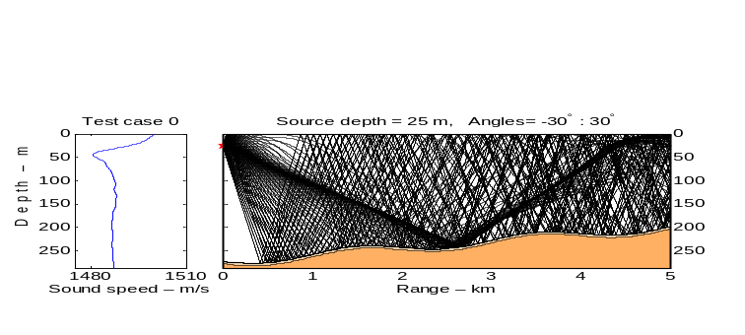
- Sound speed profile and ray traces for a typical case. The initial angles of 100 rays at the source from –30º to 30º.The number of bottom or surface reflections is in this example limited to 8 reflections.
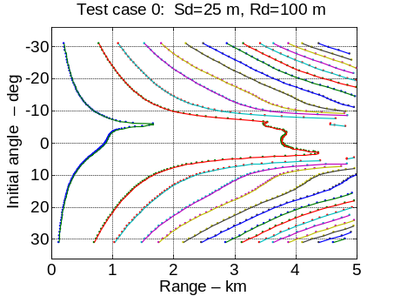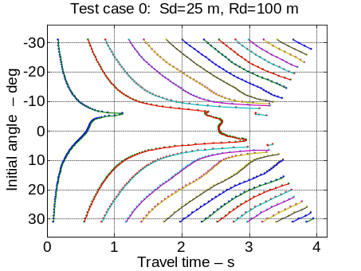
- Ray history of the initial ray tracing in Figure 1 showing range (left) and travel time (right) to the receiver depth as function of initial angel at the source.
The rays are sorted into classes with similar path characteristics and ray history. The classification is by the sign of the initial angle of ray, by the numbers of reflections at the bottom and sea surface, and by the number of upper and lower turning points, the ray has experienced. As a ray propagates from the source position, it builds a six- element vector of the form:
[Initial-angle Target-count Bottom-count Surface-count, Upper-turning-count, Lower-turning-count].
Each time the ray strikes the bottom, the sea surface, or goes through a turning point, the relevant counters are increased by one, and when the ray intersects the receiver depth line, the target counter is updated. In the simple case of a constant water depth, but arbitrary sound speed sound, there are 16 ray classes in addition to the direct path, a total of 17 classes. With range-dependent bathymetry, there may be additional classes with both turning points and bottom/surface reflections.
When the rays and the ray history have been classified and sorted, the next step is to interpolate on each group of rays separately. The interpolation is facilitated because the ranges to the receiver depth intersection increases or decreases monotonically with the initial start angle so that range versus angle is single-valued function. In most cases, the eigenrays are determined by one simple interpolation yields values that are sufficiently accurate for most application, but that depend on the complexity of the situation with respect to bathymetry and sound speed profile. Generally, the accuracy increases with increasing density of the initial angles at the cost of longer computation times. It is advisable to check the accuracy of the eigenray determination before proceeding with the acoustic field calculations

Boundary conditions at the surface and bottom interfaces
Each ray separately has to satisfy the boundary conditions at the sea surface and the bottom. This is accomplished by the use of plane-wave reflection coefficient. In the current version, the bottom is modeled with a fluid sedimentary layer over a homogeneous solid half space. For a rough bottom or sea surface, the reflection coefficient is given by the coherent reflection for rough surfaces, see sections 15.5.1 and 4.4 of [4].

Seawater absorption
The model includes the standard acoustic absorption in seawater calculated by the semi-empirical formulae by Francoise and Garrison which gives sound absorption as function of frequency, temperature, salinity, depth, and pH value, see section 3.32 of [4].

Specification of the source
The specification of the source is composed of two parts; (1) the modeling of a single source function, and (2) the directivity of acoustic transmitter. The complete source spectrum in frequency and angle then
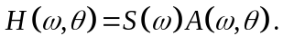
S(ω) is the frequency function of the source and A(ω, θ) is the directivity as function of frequency and the elevation angle. Note that the model is 2-dimentional (range and depth) and that the azimuth angle is not included.

Source function
The source function is specified as a pressure pulse given in time and frequency domain. This could be, for instance by loading a recorded signal, or by specifying the source signal by programming an expression. As a default, PlaneRay is equipped with a standard time function in the form of a Ricker pulse shown in Figure 3. The user sets the peak frequency of the spectrum and the time position the peak. In Figure 3, the peak frequency is 100 Hz and the time position is 12 ms.
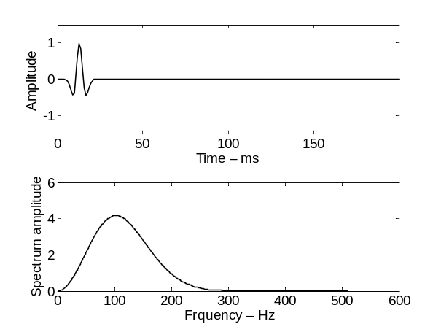
- Ricker time pulse and frequency function

Source directivity
The simplest way to introduce a (vertical) directivity is to include only initial start angles within the beam width of the source. If this is not satisfactory, the model is set up with, a facility for user-specified directivity. The current implementation allows for the directivity of a vertical array with Ne elements with paced with ∆x (meters) but other directivities can be obtained by modifying a subroutine. Figure 4 shows two examples of directivity diagrams, for Ne=8 elements with a spacing of ∆x =10 m for the frequencies of 50 Hz and 150 Hz. Notice the repeated main lobe for 150 Hz, since at that frequency the spatial sampling theorem is not satisfied, i.e. when ∆x > λ/2.
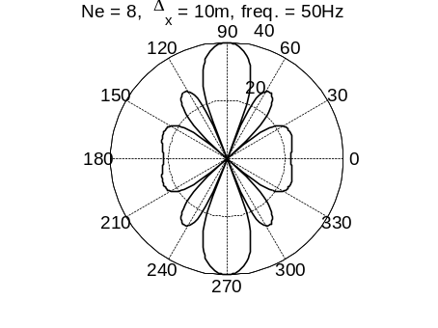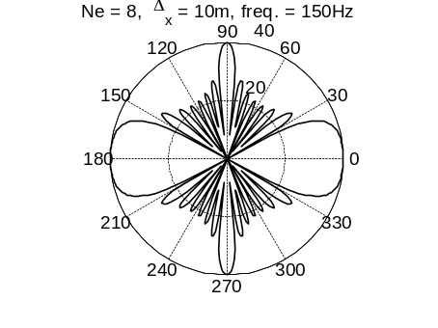
- Directivity pattern as function of the elevation angle θ for a horizontal array with N_{e}=8 elements spaced at Δx=10 m for the frequencies of 50 Hz and 150 Hz.

Synthesis of the acoustic field
The total wave field in the frequency domain is calculated by coherent summation of all eigenray contributions taking into account the phase shifts associated the travel times from the interpolated history of the travel times. The first step is to determine the geometrical transmission loss of the multipath contributions by applying equation to the sorted and interpolated range-angle plots as illustrated by Figure 2 for the current example. The geometrical transmission loss is independent of frequency
- Transmission loss
The total transmission loss is derived from the geometrical transmission loss and includes the effects of the reflections from surface and bottom and the water absorption the relevant frequencies. Figure 5 shows both the geometrical transmission and the total transmission loss for the frequencies of 25 Hz, 50 Hz, and 100 Hz for the current example. Note the values at ranges of around 3800 m. These minima in transmission loss represent the very high sound intensities at caustics and turning points.
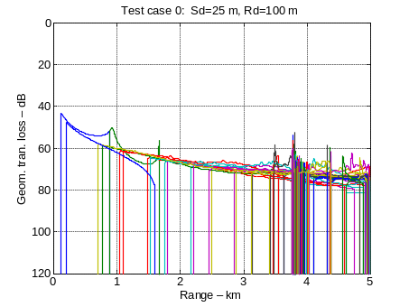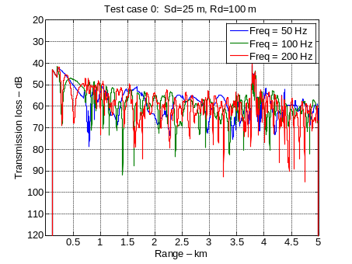
- Geometrical (left) and total (right) transmission loss as function of range calculated for the frequencies of 50 Hz, 100 Hz, and 200 Hz as functions of range.
- Time responses
The synthesis of the total acoustic field is performed by multiplying the frequency spectrum of the source signal by the transfer function of each of the eigenrays and summing all the significant contributions. This operation can be expressed by
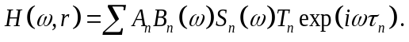
H(ω, r) is transfer function from the source to the distance r at the at angular frequency, summed over all the n=1, N eigenrays. A_{n} is the geometrical spreading and B_{n}(ω) and S_{n}(ω) contains the effects of all bottom and surface reflections, respectively. T_{n} is the accumulated −90° phase shifts associated with caustics and turning points and τ_{n} is the travel time.
Time domain solution is obtained by multiplying H(ω, r) with the frequency function of the source signal followed by an inverse Fourier transform of the product. This requires that the user define a source signal, a sampling frequency (f_{s}) and a block length (nfft) of the Fourier transform. The total duration of the time window after Fourier transform is T_max=nfft/fs. It is important that nfft and f_{s} are selected so that Fourier time window, T_{max}, is larger than the actual length or duration of the signal. In reality, the time duration of the received signal is generally not known in advanced and therefore the user may have to experiment with different values to find appropriate values.
Figure 6 shows time responses of the example as function of range and time. The multipath arrivals are color coded as indicated in the legend. The time scale is in real time, i.e. the total time between emissions from the source to the pulse is at the receiver. A more convenient plot is also shown in Figure 6 where the same time response are plotted as function of reduced time, defined as
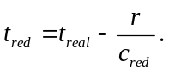
In equation , t_{real} and t_{red} are the real and reduced times, respectively, r is range and c_{red} is the reduction speed. The actual value of c_{red} is not important as long as the chosen value results in a good display of the time responses. In this example, the source signal is a Ricker pulse is with center frequency of 100Hz. The recommend minimum sampling frequency f_{s} of such a pulse is about 10 times the center frequency. Notice again the high sound pressure values at around 3.8 km caused by caustics noted previously and to be discussed caustics more in detail later.
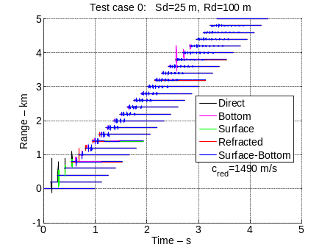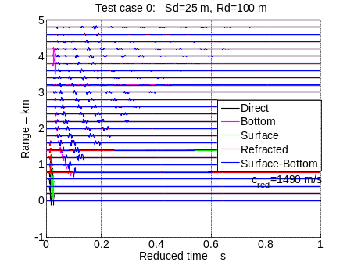
- Received time responses as function of range and plotted as functions of real (left) and reduced time (right)
Most applications and comments in this paper are on low frequency applications where the bottom properties are important. However, there is nothing in the model to prevent its use at any frequency, but there may be a practical problem with aliasing errors in the Fourier transformation to time domain. With a high sampling frequency the required block length of the Fourier transformation may be large resulting in long computation time. Alternatively, the model allows for specification of a carrier frequency that is only used when calculation the water attenuation.

Eigenray analysis
In the PlaneRay model, various multipath arrivals are treated separately and therefor can be studied independently. This is particularly useful when dealing with communication and navigation systems where only the direct arrival or the refracted arrivals may carry the useful signals and all the other multipath contributions represent interference.
Figure 7 shows, as an example, the eigenrays to a receiver located at 4.0 km from the source for the same scenario shown in Figure 1. In this case, there are 22 eigenrays for initial angles from -30° to 30°. Figure 8 shows ray amplitude as function of initial angle, and multipath amplitude as function of travel time. The amplitudes are normalized with respect to the maximum amplitude and the time is reduced time with the gross time delay subtracted. The right-hand plot can be interpreted as is the impulse response of the channel showing contributions spread out in time. Notice the three first arrives almost at the same time.

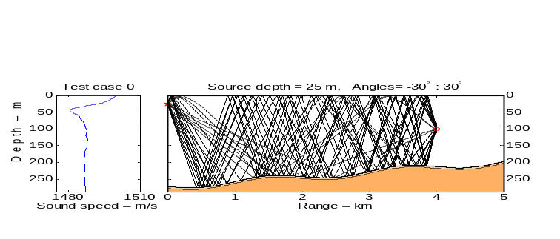
- Eigenrays from a source at 25 m depth to a receiver at 100 m depth and 4.0 km from the source.
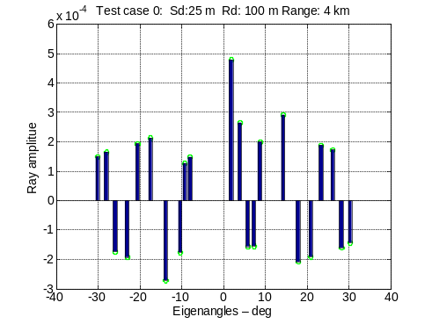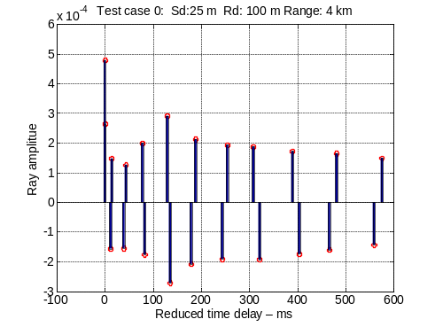
- The amplitude the eigenrays as functions of initial angle (left) and time (right). The travel time differences are relative to the arrival time of the first eigenray.

Caustics and turning points
The locations where dr/dθ₀=0 are called caustics where the ray phase is decreased by 90° and the where the intensity, according to ray theory, goes to infinity. In reality, the intensity is high, but finite, and the basic ray theory breaks down at these points. There exists theories to amend and repair the defects of ray theory [7], but such theories are not implemented in the model; the model accepts the amplitudes as resulting from the numerical evaluation of equation . Instead and as an aide in assessing problems with caustics, PlaneRay has a component that detect the locations of the turning points and caustics.
Figure 9 (left) shows the same plot as in Figure 2 of range and initial angle, but now with the detected caustics marked with red circles. Note the detection at 0.9 km and the detected cluster of detection around 3.7 to 4.1 km, which indicates anomalous high sound levels for the ranges at these distances.
Figure 10 shows the sorted geometrical transmission loss (left) and the total transmission loss (right) as function of range sorted with respect with respect to the type of multipath contribution. The total loss is calculated for the frequency of 100 Hz and incorporates absorption loss and bottom reflection losses. The peaks in the geometrical loss at 0.9 km and around 3.8 km is a warning of possible accuracy problems at these ranges, but only the peaks around 3.8 km seem to be important.
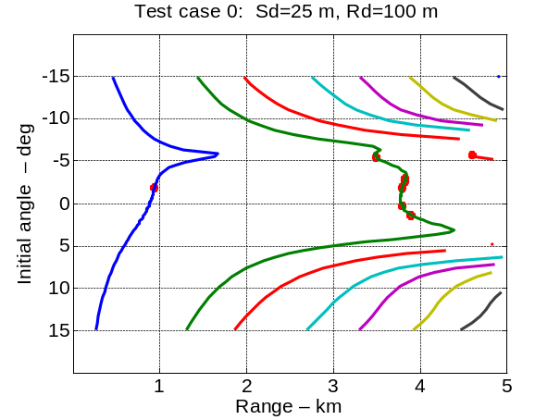
- Locations of caustics and discontinuities in the plots of Figure 2.
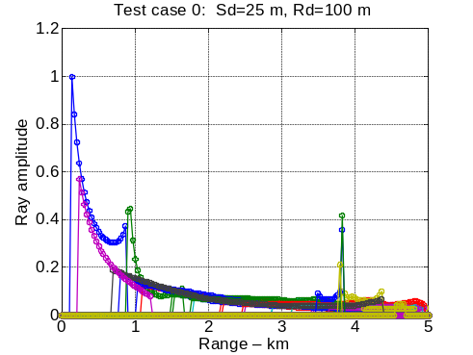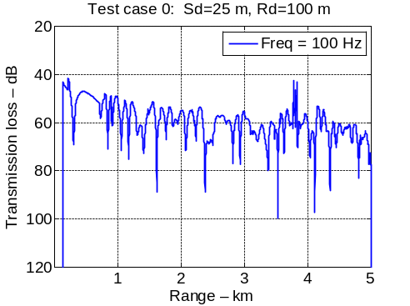
- Geometrical transmission loss (left) and total transmission loss in dB (right)

Producing results as function of depth
PlaneRay is organized such the natural output is as function of range for fixed source and receiver depths. Determination of the sound field as function of depth is, for instance required when using a vertical receiving array. In for such situations it is required to set up a loop for repeating the ray trace calculation at the required receiver depths.
The depth version of PlaneRay is initialized by typing “planeray_depth” and specifying the case to be considered. Then the user is then requested to specify a single range and a set of depths. Figure 11 (left) displays an example of the accumulated results showing the time responses at the depths at intervals of 25 m from the surface to 260 m. The right hand figure shows the sound level, in dB re 1µPa, at 2 km distance from the source and at 25 m depth for the frequency of 100 Hz, assuming a source level of 200 dB re 1µPa. Finally, Figure 12 shows the contoured transmission loss in dB as function of range and depth.
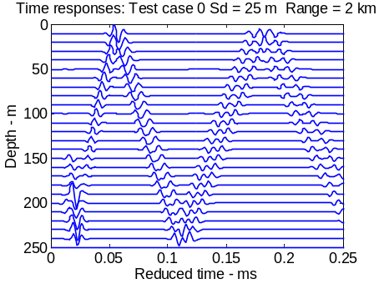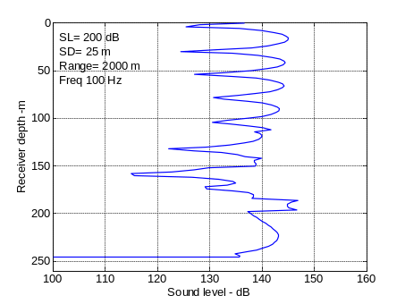
- Time response (left) and sound levels (right) as function of depth at a distance of 2 km from a source at a depth of 25 m
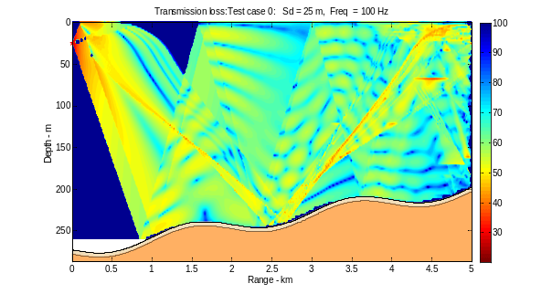
- Contoured transmission loss in dB as function of range and depth.

Accuracy of PlaneRay and testing with other models
Ray tracing is high-frequency approximated to the solution of the wave equation and therefore the accuracy and validity at lower frequencies may be questioned, in particular the use of plane-ray reflections coefficient to represent the bottom effects.
The example compares the PlaneRay model with the wave number integration model OASES [8]. The scenario is a Pekeris waveguide with constant water depth of 100 m and constant sound speed of 1500 m/s. The bottom has a fluid sediment layer with thickness 5 m over an elastic halfspace. The sound speed and density of the sediment layer is 1700 m/s and is 1500 kg/m³, respectively. The elastic half-space is a hard bedrock with compressional speed of 3000 m/s and shear speed 500 m/s with density of 1800 kg/m^{3.} All wave attenuations are set to 0.5 dB per wavelength. The bottom reflectivity, which is a function of frequency and angle, is modeled in the same way in the two models, includes bottom attenuation, and shear conversion. This case is relevant for assessment of the accuracy of ray theory and the use of plane-wave reflection coefficients in representation of the bottom interaction.
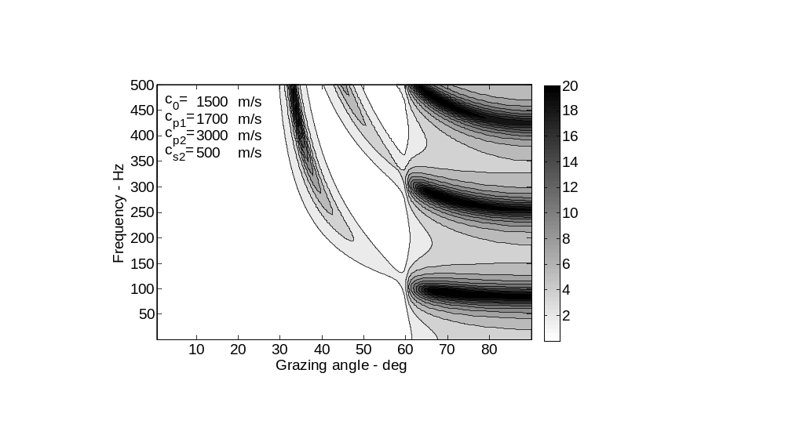
- Bottom reflection loss (dB) as function of frequency and incident angle for a bottom with a sedimentary layer over a homogenous solid half space.
Figure 14 comperes the transmission loss as function of range calculated by PlaneRay and OASES for the frequencies of 25 Hz, 50 Hz, 100 Hz and 200 Hz. The two sets of results agrees well, except for the lowest frequency of 25 Hz. At this frequency, the wavelength is about 60 m such that the receiver height above the bottom is less than half of the wavelength. This agrees with theoretical results [6] showing that source and receiver should be at a height above the bottom of at least half a wavelength. Note however that there are similar requirement to the distance from a perfectly reflecting sea surface.
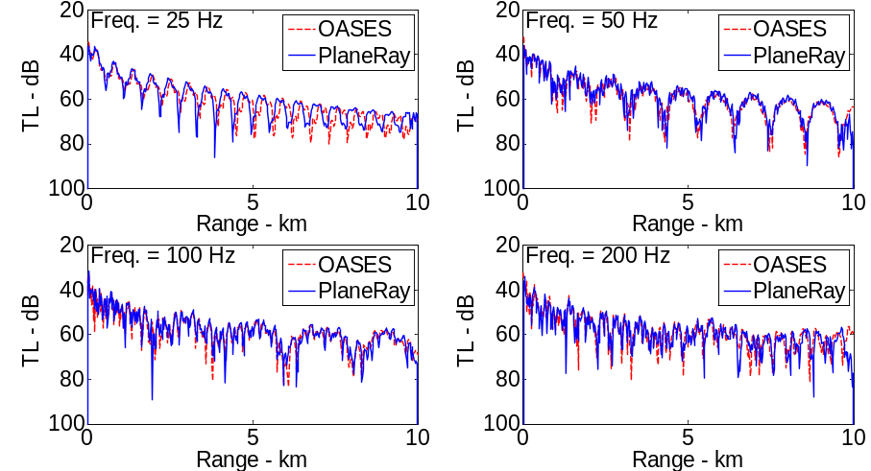
- Comparison of the transmission loss as function of range for different frequencies by PlaneRay and OASES for Pekeris’ waveguide with a layered bottom with parameters given above

Running the PlaneRay
To run the program correctly, the users need to have an understanding of ray theory and underwater acoustic propagation. The input parameters need to be consistent with the theory and limitations of ray theory. The program does not check the input parameters and, if anything is wrong, the program may crash without warnings.
The core is the calculation of ray trajectories based on the inputted sound speed profile, the bathymetry and the source position. It is the responsibility of the user to provide correct input information. Here are some points to observe:
The sound speed profile must contain values for all depths. The program will crash without warnings if a ray reaches a deeper depth than covered in the sound speed profile. The sound speed profile taken from a CTD recording are often sparse and may end at a depth where the operator has decided that the temperature and the salinity have reached constant values. In such cases, the sound speed profile must be extrapolated to the bottom.
PlaneRay interpolates the inputted sound speed profile to equal spaced depth intervals (specified by the user in the input file). The interpolation routine requires that the depth values are monotonically increasing or decreasing. Sometimes this is not the case because the CTD instruments have been moving up and down during lowering or recovery. The user has to filter out these variations before submitting to the program. The user can specify the method of interpolation by setting the parameter “sspmethod” to for instance ‘linear’ or ‘spline’. If the inputted sound speed profile is sparse, the interpolation, especially the spline interpolation, may create unrealistic values that may cause false caustics. It is a good practice to check the interpolated profile before starting the calculations. What is said about the sound profile also applied to the bathymetry, here the parameter ”bathymethod” determines the interpolation method.
The code is written in Matlab to facilitate flexibility and adaptively to satisfy specific user needs. In terms of running time, the model may be slow, but here are some guidelines for considerations.
The running time for steep rays may be long because of the many reflection for reaching a given range. The running time may be reduced by restricting the number of bottom and surface reflections by setting the parameter “ bottom_reflections” and “surface_reflections” to a minimum.
The time plots are derived by Fourier transformation of the product of the source function and the transfer function. The user has to specify the sampling frequency and the FFT block length in such that aliasing errors in range and time is are within acceptable limits. For long ranges and many receiver phone positions, the required FFT block length may high requiring significant computer time.

Summary
The PlaneRay model is an acoustic propagation model intended for use in moderate range dependent environments. The complete acoustic fields are calculated by coherent addition of the contributions of a large number of eigenrays. Rays are not traced into the bottom, and the bottom interaction is modeled by local plane-wave reflection coefficients. Ray tracing calculation is, by definition, frequency independent and therefore the calculations of ray trajectories through the water column are not dependent on frequency. Frequency dependency is introduced separately afterwards with the bottom or surface reflection coefficient, by layering and absorption, or by diffuse scattering of rough ocean surface or bottom interface. Therefore the ray tracing and the determination of the eigenrays need to be done only once for each scenario, i.e. for a fixed bottom topography, sound speed profile and source and receiver depths. Since these calculations are the most computational intensive parts of the code, the model is quite efficient for broad frequency band calculations and consequently for the calculation of time responses.
Ray tracing modeling is a useful technique for applications moderately range dependent environments and, as such be a valuable addition and alternative to other models with different advantages and limitations.

References

Officer, C. B. Introduction to the theory of sound transmission. McGraw-Hill, New York City, (1958)

Jensen F. B., W. A. Kuperman, M. B. Porter, and H. Schmidt, Computational Acoustics, AIP Press, New York Jersey, (1993).

Porter, M. B. The Kraken normal mode program. Rep. SM-245. SACLANT Undersea Research Centre, (Nato Undersea Research Centre), La Spezia, Italy, 1991.

Hovem, Jens M., Marine Acoustics –The Physics of Sound in Underwater Environments, Peninsula Publishing, Los Altos CA, USA 2012

Hovem, Jens M, Ray trace modeling of underwater sound propagation Documentation and use of the PlaneRay model.
SINTEF ICT Reports 20 -11- 13

Hovem, Jens M. "Ray Trace Modeling of Underwater Sound Propagation," in Modeling and Measurement Methods for Acoustic Waves and for Acoustic Microdevices, InTech, Rijeka, Croatia, [2013]. ISBN 978-953-51-1189-4

Brekhovskikh, L. and, Lysanov, Yu. Fundamentals of Ocean Acoustics, Springer-Verlag, Berlin Heidelberg New York, 1982

Schmidt H., SAFARI. Seismo-acoustic fast field algorithm for range independent environments. User’s guide, SR-113, SACLANT Undersea Research Centre, La Spezia, Italy (1987).

